**Book Component Implementation**

Inside the components create a component named book and create the following folder structure

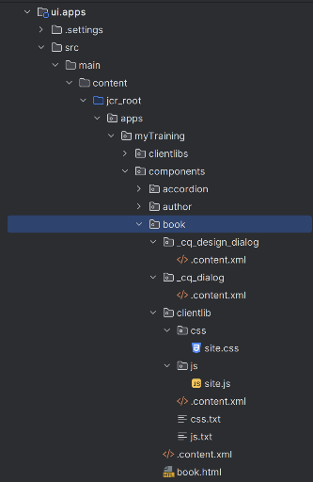

Inside the **_cq_design_dialog .content.xml** add following code

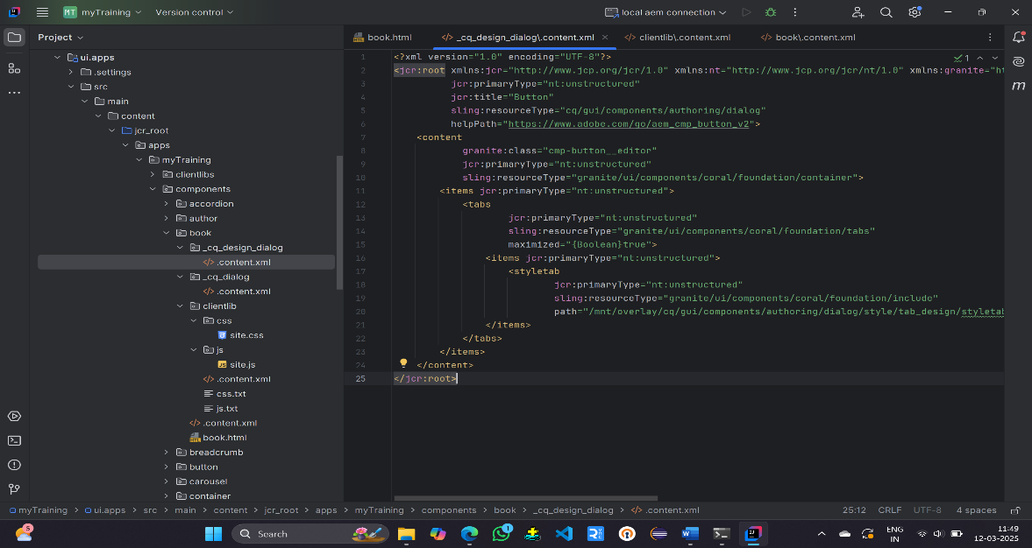

Inside the **_cq_dialog .content.xml** add following code

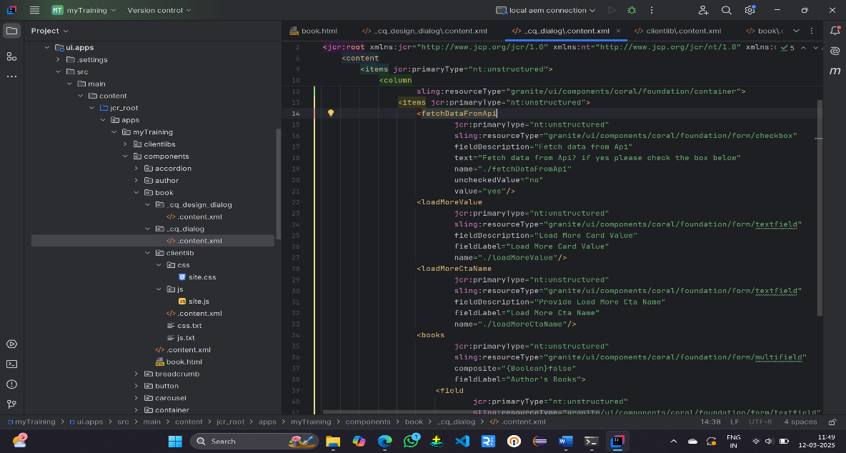

Inside the **clientlib** add following code

**Site.css**

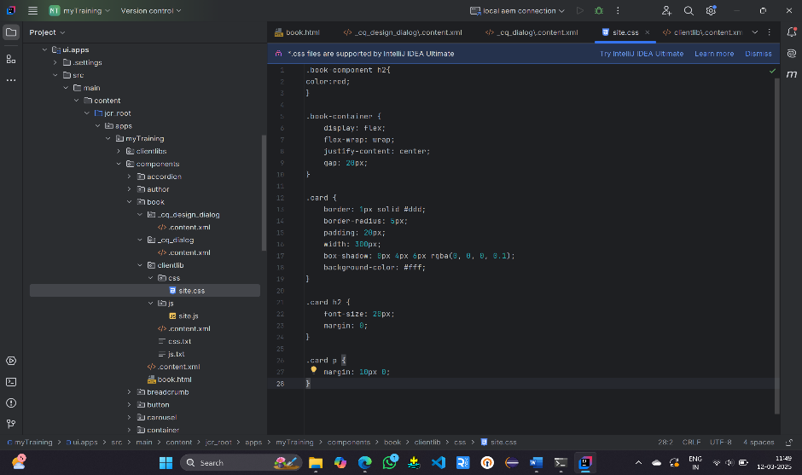

**Site.js**

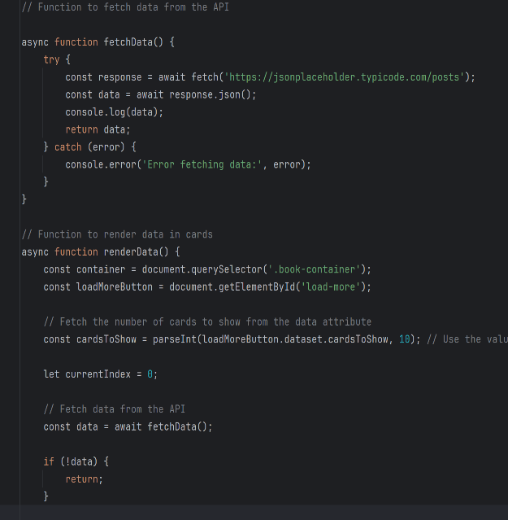 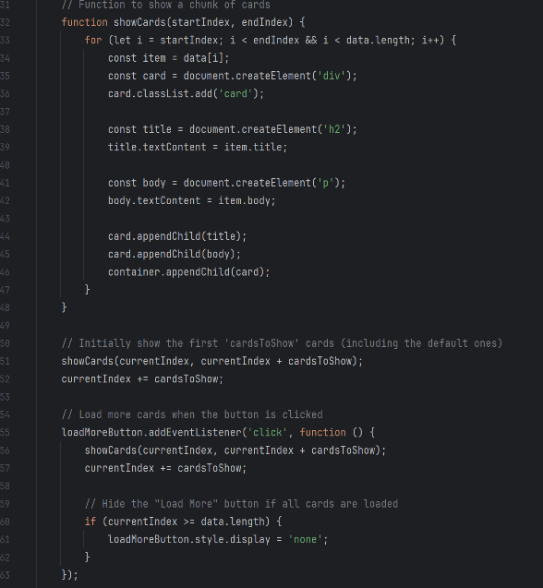

**.content.xml**

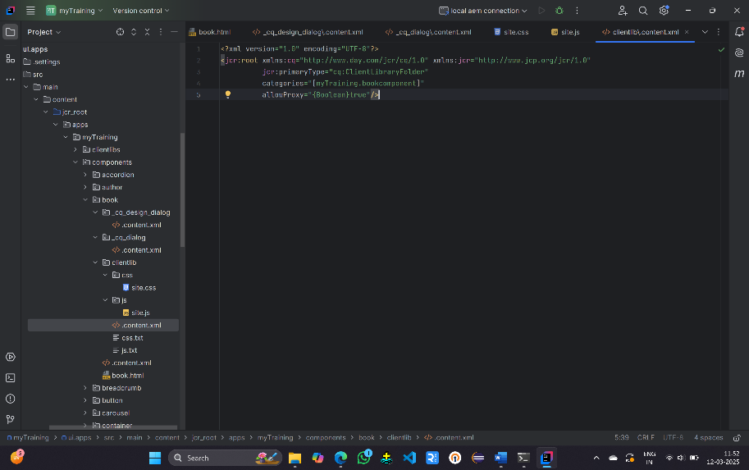

Inside the **book .content.html** add following code

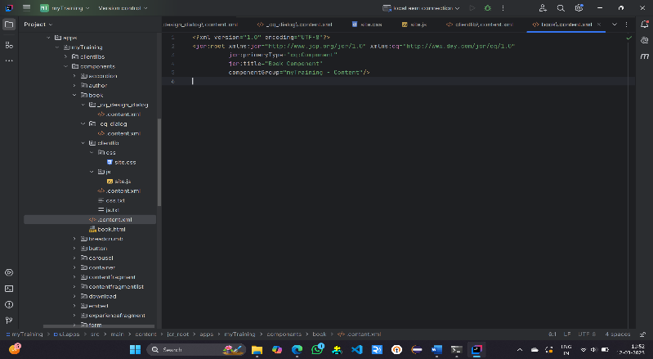

Inside the book.html add following code

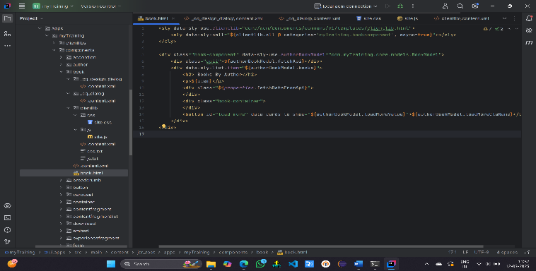

Inside com.myTraining.core modals write the following code

**BookModal.java**

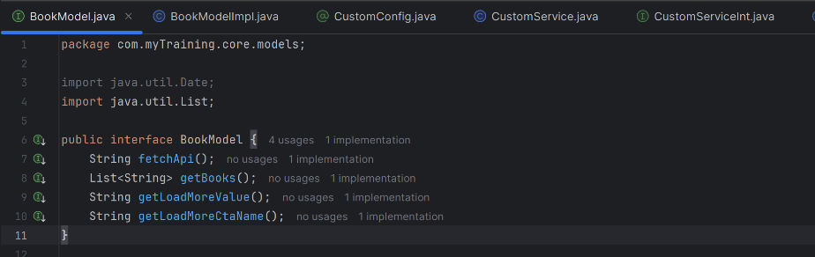

**BookModelImp.java**

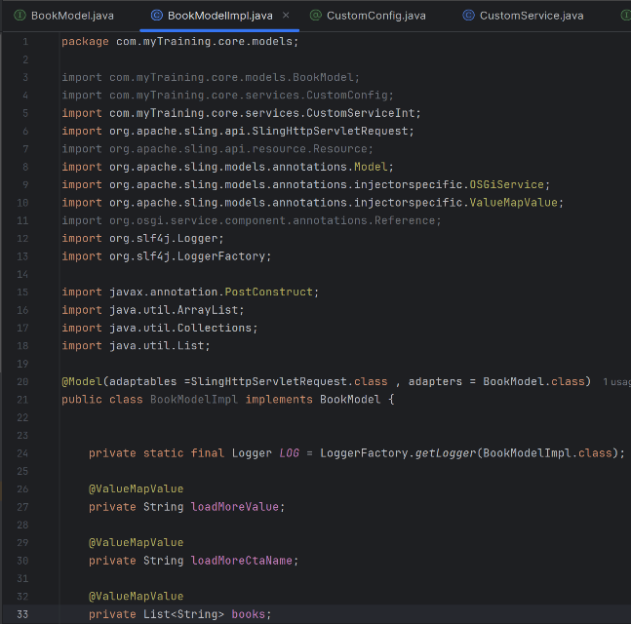 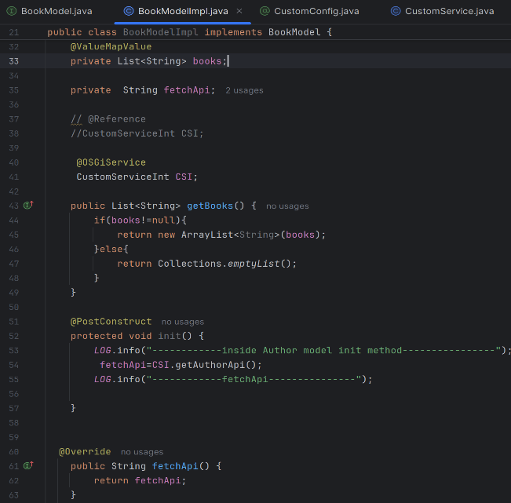

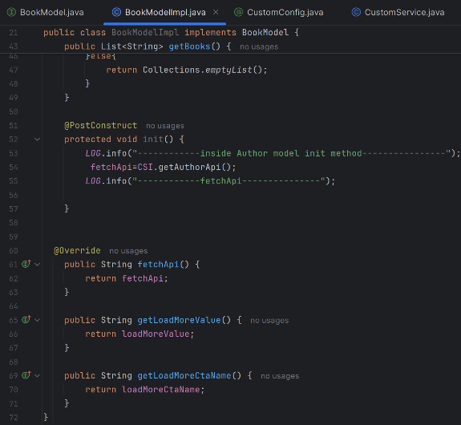

Now open AEM and add Book component in the author page

Fill the following fields

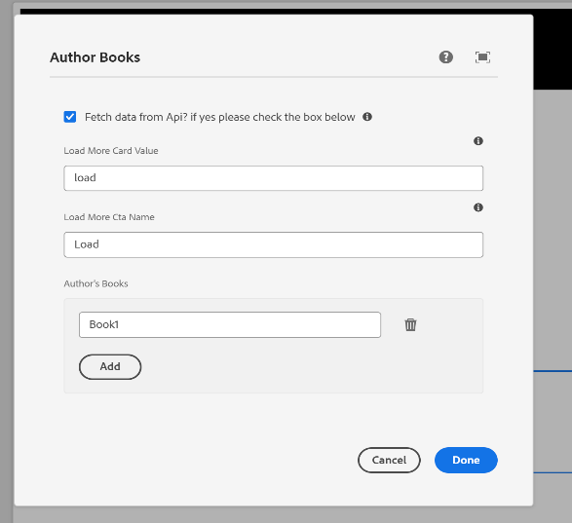

**Output**

